CENTRALIZING CANTEEN in IITK CAMPUS

AIM- we aim to develop a website where all the canteen owners can login through their ids and then add the amount of a particular student by their roll number or their name. At the end of each month each student would get mail of their monthly bill, they will then pay their money to the app, and the app distributes the money to the canteen owners.

The website would enable students to buy from any canteen (hall canteens/DOAA/ CC canteen/ SL canteen etc).

It would make it easier for students to keep track of the bills and the student can view their bill at any point in time. It would also remove the need to pay at every canteen and tackle struggles like UPI servers down.

Language/Databases used or needed-

HTML, CSS, JS

ReactJS, SQL from backend

Things that need to be implemented-

Mail automation and bill payment method

Student search database for searching student.

FEATURES OF SITE-

LOGIN PAGE-

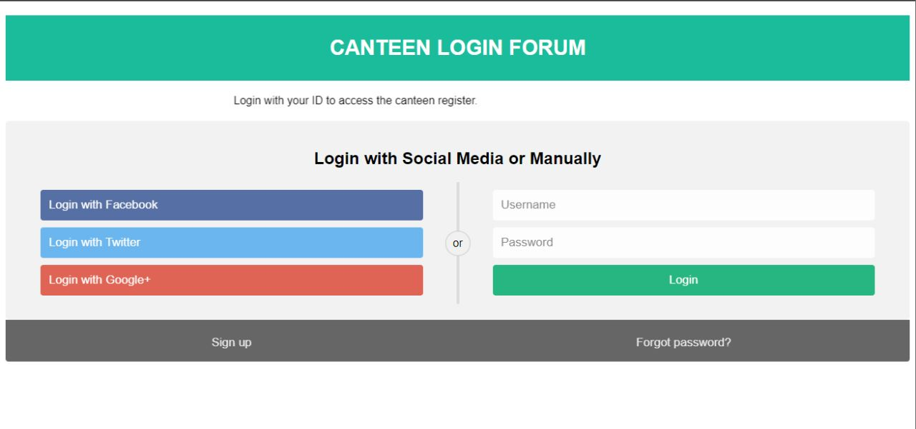

A user can register using the signup button, there are various methods of login in – such as facebook, twitter, google+. Once logged in the page will be redirected.

The canteen owners when login will be directed to page wherein, they can add amount to the student’s database.

If the student logs in, they can view their current bill.

SIGNUP PAGE

The student will enter their iitk email id and then set password for it. It also has a option of remember me wherein the details of students will be saved on their device.

Once registered the student will be redirected to the login page.

CANTEEN OWNER LOGIN

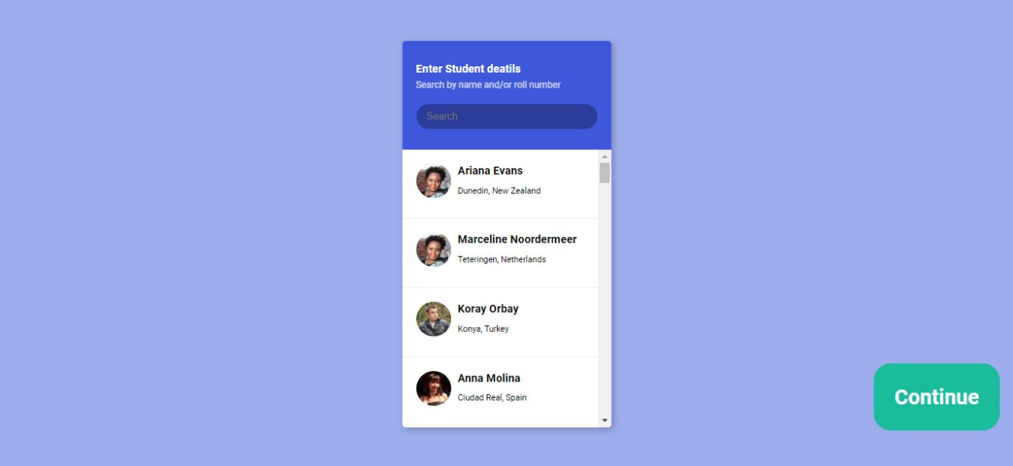

When a canteen owner logs in he will be directed to the page wherein they can select the student by their roll number or name, once selected then they can press on continue, the individual students profile will open up. The data for this will be taken for student search database.

SQL can be used to store the database.

STUDENT PROFILE-

when a canteen owner selects a student, it will open up his profile, it contains the name, roll number and image of the student. The table consists of amount and the item purchased, it will also show the date product is purchased on.

The owner types in the details and then presses on add .

It adds the bill of the student.

We have not yet added the backend framework.